**2004:**

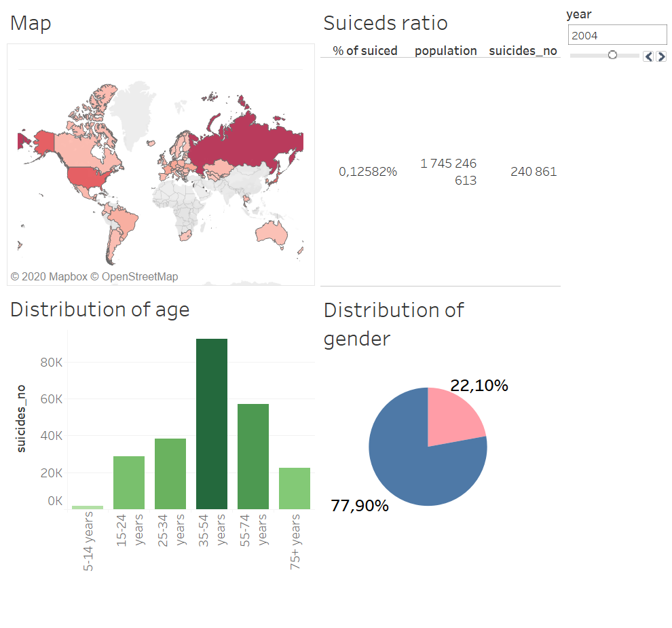

**2015:**

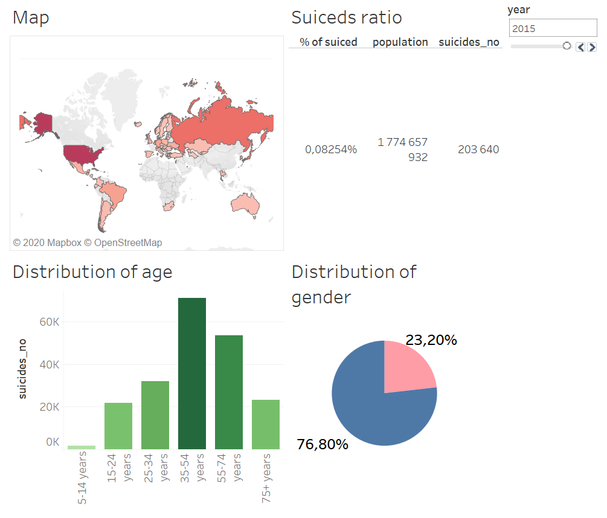

Observation:

* The ratio of Number of 55-74 years old and Number of 35-54 years is changed through the years !
* The number of suiced femal people is increased through the years.
* The overall percentage of suiced people and population is decrased.

Let’s focus on Hungary.

* The situation is same like the global picture.

